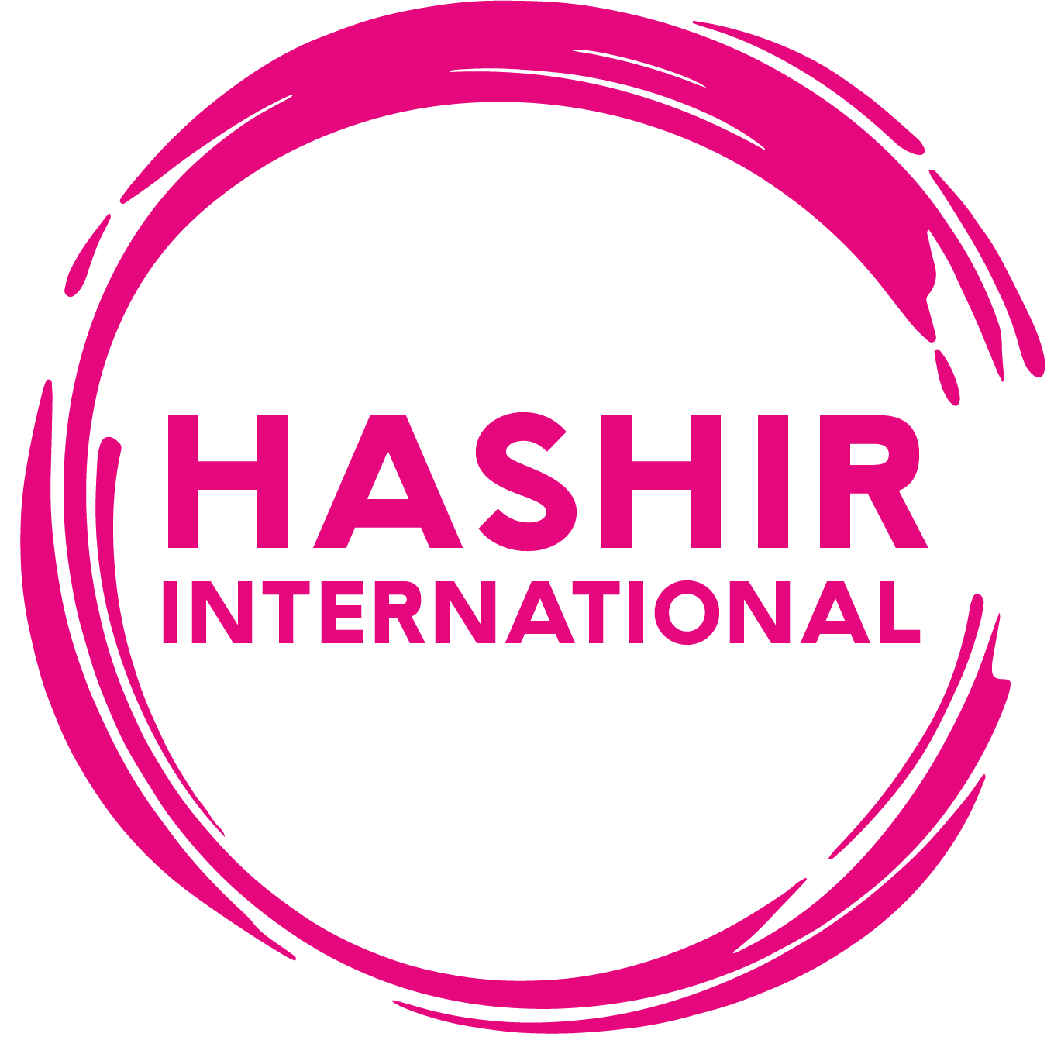
Hybrid Tinnitus Masterclass: A Comprehensive and Advanced Neuro-Psycho-Audiological Cognitive Behavioural Therapy Training Course for Tinnitus and Sound Intolerance Rehabilitation
This is a hybrid training course. It starts with 3 days face-to-face lectures on 10-12 March 2025 at Birkbeck college, University of London, followed by 12-month online training course and clinical supervision. Organizer is Hashir International Specialist Clinics & Research Institute for Misophonia, Tinnitus and Hyperacusis Ltd.
Course Fee (includes 3-days face-to-face lectures 10-12 March 2025 in London, 12 months online course, 12 monthly supervision sessions, assessment and certification)  Saver (deadline: 15th December 2024): £2500  Early bird (deadline 15th January 2025): £2750  Standard (after 15th January 2025): £2850 | This price includes the training fees only. Students are responsible for their own food and drinks as well as accommodation and transport arrangements.  Refund Policy: A £75 processing fee will be charged for refund requests made within 28 days of payment. After this the fee is not refundable. In addition, the fee is not refundable 2 months prior to the start of the course.
How to Register? Places will be booked on a first-come-first-served basis. Please complete the application form below and send it as an email attachment to admin@hashirtinnitusclinic.com

First name: Surname: Title: Mr/Mrs/Ms/Dr/Prof/other

Date of birth:

Where did you hear about this course?
Profession and Degree:

Address:

Telephone: Email Address:
What learning outcomes (clinical, research, service development) would you like to achieve in this event? (The information that you provide here will assist us in tailoring the course to meet your needs)

Briefly describe your previous experience regarding assessment, management or research on tinnitus and hyperacusis (100 words):

